ELVISH WORD TRANSLATOR

[Elvish Translator (funtranslations.com)](https://funtranslations.com/elvish)

CHARACTER NAMING

[Elf Name Generator (fungenerators.com)](https://fungenerators.com/name/elf/)

Language for Noble Empire

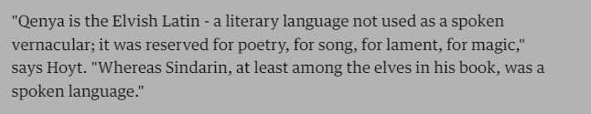

For Common people

